**Software Engineering Principle 13016214**

Project Report



Phonology Teaching Application

**58090002** Damian Satya Wibowo

**59090025** Punn Ouilapan

**59090038** Warakorn Jetlohasiri

Software Engineering, International College KMITL

**I. Linguīs Project Description**

Linguīs, meaning ‘into languages’ in Latin, is a phonetic learning software which aims to provide learners of languages and linguistics the resources and tools to make their phonology learning process more effective and convenient. It also aims to serve as a resource hub for easy access of language and linguistics knowledge. The app will achieve said goals by offering features such as the International Phonetic Alphabet chart completed with pronunciations, as well as access to various phonology topics. The users will be able to mark their most used topics, as well as IPA characters, for quick access.

The application will be written in Python 3 and will utilise PyQt5 to render its Graphical User Interface. This is to illustrate the powerful capabilities of the Python programming language, as well as the flexibility of the Qt GUI framework.

The application will be split into four primary sections as followed:

**International Phonetic Alphabet**

The IPA Chart section will consist of two parts. The latter part is a complete interactive chart of all the International Phonetic Alphabet glyphs, which users can interact with to hear the pronunciation in its initial, medial and final position (consonants) and independent position (vowels)*.* The users will also be able to save the character to their favourites list for easy access.

**Phonology Information Hub**

The Information Hub section will consist of a database of information on phonology topics, including an overview containing information about International Phonetic Alphabet and its usefulness. Each topic in the information hub will also be able to be favourited for easy access. Users can expand the information by installing additional databases or revisions into the application.

**Quizzes**

There are sets of quizzes which can be used to test and check the learning progress of the user. Three types of questions are: 1. Multiple choices, where a user should choose one correct answer out of five options; 2. True/false, deciding whether a statement is true or not; 3. Fill-in-the-blank, where a user should fill the correct answer.

**Favourites**

The Favourites section is will contain all the glyphs and information topics that the user has marked to allow the user to access them easily. The favourites will be organised systematically according to their type: phonemes and content topics.

**Extra: Updater**

Linguīs can be updated! An updater file is a separate program to update the firmware of Linguīs.

**II. Software Requirements**

**User, functional requirements:**

1. Linguīs provides user to listen to each IPA symbols’ pronunciation at initial, medial and final position (consonants) and independent position (vowels).
2. Linguīs provides arrays of information about various topics about phonology.
3. By doing the questions in the quiz section, user can train their phonology knowledge.
4. Users are able to save their favourite topics and IPA symbols into Favourites list.
5. The text-to-speech section is able to convert IPA text into an audio output.
6. Outputted audio from the text-to-speech section can be saved to user-specified location.
7. Users can update the application to the newest version by installing update through the options menu.
8. Users can report bug to the developer.
9. Users can preserve their login information (‘remember me’ section) in the login page.
10. Users can pronounce their favourite phonemes and/or jump to their favourite articles.

**User, non-functional requirements:**

1. Users need to fill in their e-mail address in order to get notified in some cases.
2. The user interface will be easy to navigate, with information categorised into sections.
3. Information about the development of Linguīs as well as its Github page will be available within the application.
4. Linguīs is provided in English.
5. There is a help menu that provides users a guide to operate the application and navigate between menus.
6. Favourited topics are saved in a separate favourite menu.
7. Quizzes’ are equipped with scores and evaluations to tell user their progress and recommended future study.
8. User statistics and account information can be seen from the Options menu.
9. The favourited topics are bound to the specific user account.
10. Every user account is protected with a verified password.

**System, functional requirements:**

1. The text-to-speech converts IPA symbols and match the sequence with its corresponding IPA pronunciation sound file, and play the sequence.
2. Update is installed by calling the updateApp() function inside the Updater object in a separate Updater application which will modify some specified application data which are updated.
3. The text-to-speech output file can be saved into the local storage as a .wav file.
4. The application can evaluate quiz results by accumulating weighted scores in various topics.
5. When a quiz is open, list of questions is load to the QListWidget, then selected question and its answer field are shown in a QWidgetStack object besides the QListWidgetList.
6. Quizzes are stored in a text file named quizzes.txt which contain a formatted text. Loading quiz involves parsing the text file into QuizList objects, and ultimately, broken down into quizzes.
7. User can jump from favourite content to the page viewer directly, by hiding favourite tab and showing the user’s ContentUI panel on the index of the selected favourite content.
8. User can play favourite phoneme directly on the favourite phoneme panel by calling AudioPlayer class and passing the phoneme to be played.
9. When the user quits the main menu/logging out, user’s newly user obtained/modified data is stored to userlist pickle file.
10. Report via email is done by using smtplib, and send the report to developer’s email: linguissep@yahoo.com

**System, non-functional requirements:**

1. The user interface of the software will be modelled or designed with PyQt5 Graphics User interface library.
2. The software requires PickleDB in order to provide approximately 4 files for different types of data collection. These different files will be used to collect different types of data information based on variety usage. For example, database for registration system, user list, etc.
3. The software maintenance and development will be controlled and implemented under GitHub software version control system.
4. All of IPA symbols and its corresponding IPA pronunciations’ audio file will be stored in local storage and mapped in a dictionary (stored as key and values) which reduce difficulties for visualization needed for implementation and software maintenance
5. The software user interface supports the minimum screen resolution of 900 x 600 pixels which generally supports the majority of monitoring devices in worldwide.
6. The application is written in Object Oriented Concept, using Python 3.
7. In case of a system error, an exception handler will be triggered to notify user or/and close the application.
8. Linguīs involves the MVC (Model, View, Controller) concept in its software design.
9. User IDs cannot be duplicate in the same device, and passwords should comply with certain format: contains at least one lowercase letter, at least one capital letter, at least one numeral and at least one symbol, and the length should not less than 6 or more than 12 character.
10. The user’s favourites list is stored locally, inside lists in the User class.

**III. Use Cases**

1. User > Register Account

Basic case: User successfully registers for Linguīs account.

Alternative case: User cannot register if they choose a username that has been registered before, or the password format does not comply with the requirement.

Exceptional case: In case that suddenly userlist.p file is inaccessible, user cannot register.

1. User > Login Account

Basic case: User successfully logs in to their account.

Alternative case: If user gives the wrong username-password combination, the user needs to re-enter a correct credential.

Exceptional case: In case that suddenly userlist.p file is inaccessible, user cannot login.

1. *User > Access submenu, basic case: user opens a submenu from main menu.*
2. User > Access IPA screen, basic case: user opens the IPA Laboratory from main menu.
3. User > Play IPA sound, basic case: initial, medial and final (consonant); independent position’s (vowel) pronunciation for an IPA phoneme is played.
4. User > Play text-to-speech, basic case: the sequence of phonemes is generated and played at once.
5. User > Save pronunciation to favourites, basic case: the phoneme is saved to the particular user’s favourites list.
6. User > Access material screen, basic case: user opens the material/contents from main menu.
7. User > Select material, basic case: user selects a content title to be viewed in the right panel.
8. User > Save material to favourites, basic case: the material is saved to the particular user’s favourites list.
9. User > Access quiz screen, basic case: user opens the quiz list window from main menu.
10. User > Select and load quiz, basic case: user chooses a quiz to open.
11. User > Do quiz, basic case: user answers questions in the quiz and submit the answers, then system tells user which question the user did correctly or not correctly, and tells the score.
12. User > Access favourite screen, basic case: user opens their favourite list window from main menu.
13. User > Pronounce favourite IPA, basic case: the system plays the sound for the corresponding selected IPA symbol in the user’s favourite list.
14. User > View Favourite material, basic case: the system opens the page which contains the material part, select and view the corresponding selected material title.
15. *User > Remove favourite, basic case: remove an item from a favourite list.*
16. User > Remove favourite IPA, basic case: remove an IPA phoneme from the phoneme favourite list.
17. User > Remove favourite material, basic case: remove a content title from the content favourite list.
18. User > Save phonetic sequence audio file, basic case: saving the .wav file of a corresponding IPA sequence inputted in the text-to-speech text field.
19. User > Access option screen, basic case: user opens option menu window from main menu.
20. User > Report bug, basic case: user sends their bug report to the developer, which will be sent through a hidden e-mail connection.
21. User > Update software

Basic case: user locates an updater package, which will update the software to a later version.

Alternative case: user locates an updater package, but the application is already in the current version. Nothing is changed.

Exceptional case: user locates an updater package but it is invalid. Nothing is changed.

Use case diagram:

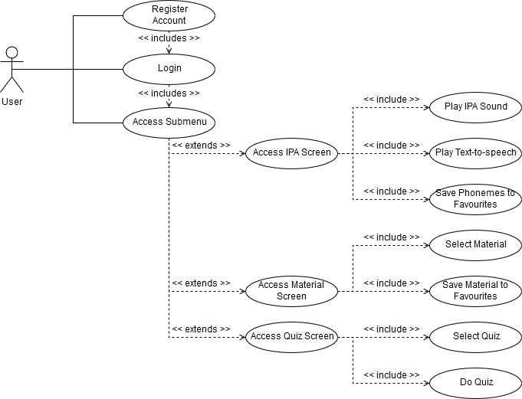

**V. State Charts**

1. Material/content

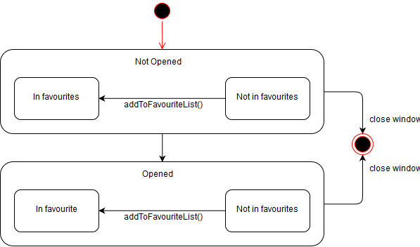

2. Quiz

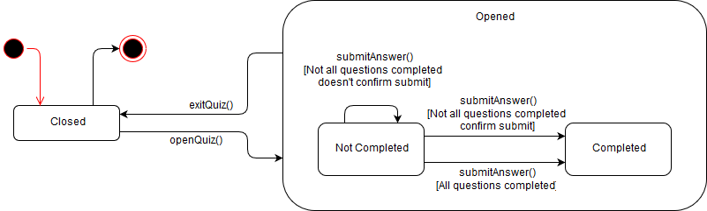

3. Text-to-speech

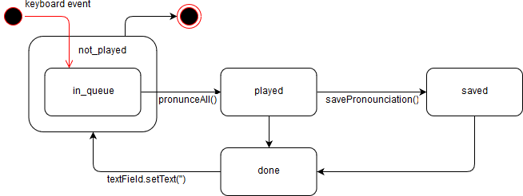

**VI. Screenshots**

|  |
| --- |
| 1    Fig. 1: Initial registration/login window  Fig. 2: Registering for Linguīs    Fig. 3: Non-matching password  Fig. 4:Password does not comply with the constraints    Fig. 5: Signed up successfully    Fig. 6: Welcome e-mail    Fig. 7: Login, and ‘remember me’ feature  Fig. 8: Login successful    Fig. 9: Main menu    Fig. 10: IPA Laboratory, pronounce alphabet mode    Fig. 11: IPA Laboratory, Text-to-speech mode    Fig. 12: IPA Laboratory, add to favourite mode    Fig. 13: IPA Laboratory, save pronunciation    Fig. 14: Material/content page    Fig. 15: Quiz list page    Fig. 15: Multiple choice question    Fig. 16: True/false question    Fig. 17: Fill-in-the-blank question    Fig. 18: Submitting quiz before answering all questions    Fig. 19: Quiz result    Fig. 20: Favorites panel    Fig. 21: Options menu    Fig. 22: Send bug report    Fig. 23: Developer receives bug from user. |